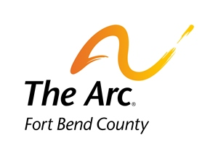
2016 Board Meeting Schedule

January 25, 2016 July 25, 2016
March 28, 2016 September 26, 2016
May 23, 2016 (Annual Meeting) December 19, 2016

